**ENSE 374 – Group07 (MVP 1) – Clean Code Review**

In our source code (“main.html”, “professors.html”, “score.hml”, “sign_up.html”, “sign_in.html”), it is clean because each element has its own unique class or identifier making it very loosely coupled. Any changes we make in the CSS will only effect that specific element, making it orthogonal as well. We have proper class and id variable names as well, making it easy for debugging, and as such, we gain more productivity because of this. 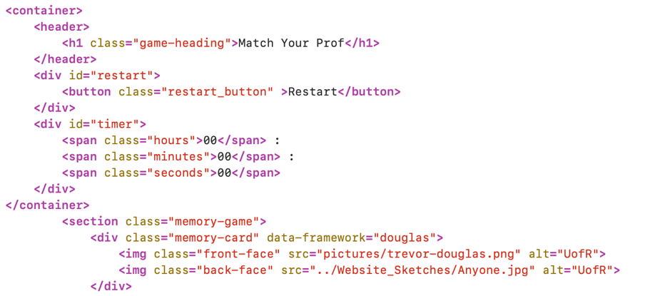

In our JavaScript code “Cards.js” it is not clean because we have very long live times for variables, some variable names are not appropriate, and overall it doesn’t look nice. Our plan is to fix this as soon as possible so we can continue developing our code with high productivity. However, it is clean in some sense; by having proper looping control statements, being orthogonal with separate functions, and instantiating all variables.

